Kingsburg Church of the Nazarene
Feb 21, 2021
Trust in the Lord with all your heart, lean not on your own understanding. In all your ways acknowledge Him and He will direct your paths (Prov. 3:5-6)
Welcome – We are Thankful You are Here!

Glorious Freedom
Christ is Enough
Reckless Love
I Love You Lord

Children’s ages 3 thru 4th Grade are dismissed for children’s church.
Please pick your children up in the Ministry Center. Classes available for 3-5 yr olds and Elementary ages thru 4th Grade

Sharing God’s Word…………..Pastor Jose Teron,
Maranatha Church

Please Drop your tithes and offerings in one of
the boxes in the Foyer, or mail your check or use
Tithe.ly App or your phone or online,
Please consider checking the box at the bottom of the app that says “Cover Fees”
That way the church will receive your intended amount

Next week, Feb 28th is Local church elections and ALABASTER Sunday

This Week in Church
After Worship………………………………….Church Board Meeting
Tonight 6 pm ……………….…..………Sunday Evening Service
Tues 9 am ………………..…….………..……….Ladies Bible Study
Wed 6:30 pm…………………….…..………Wed Night Programs
Thursday 6:30 pm ……………………….Sunday School Board
Thursday 6:30 pm………………...…Prayer time in Sanctuary
Thursday 7 pm……………..……….................Ladies Bible Study
Next Sunday 9am……….……….....Sunday School for all ages

All Church Prayer Time – Thursday at 6:30pm
We will meet in the Sanctuary. So many things to be in prayer for: God’s will and direction in every decision, unity in our church family, our search for a new Pastor, Church elections of new leaders, health and well-being of our families, healing for loss.
Come pray with your church family.

Wednesday Night Programs
Youth Games 6PM
All other programs run 6:30pm to 7:30pm
Young Women’s Bible Study (Grey House)
Kid’s Program ages 3yrs-6th Grade (Ministry Center)
Youth Girls (Jr High Room)
Youth Boys (Fellowship Hall)
Men’s Bible Study (Volunteer Room)

Welcome to the family Isla Rae Borgstadt
born Thursday Feb 19th
7 lbs 14 oz, 21” Long.
Welcomed home by Sean and Courtney Borgstadt, Big Sister Kate
Grandparents – Sharon & Larry King
Great Grandparents - Al & Linda King
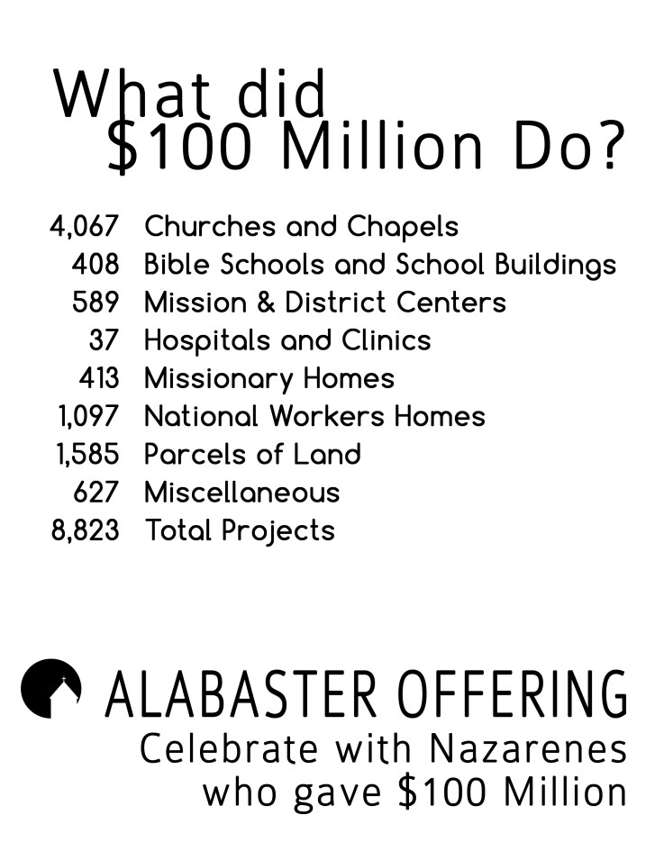
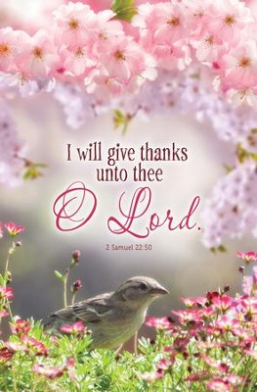

Be sure to pick up your offering bank in the foyer and start praying now about your gift to build the Kingdom. Alabaster Sunday Feb 28th

